

Feasibility Study

Report

**Restaurant Management System**

**Submitted by Muhammad Saaim**

**CLIENT: Mr. Saleem (Food n Spicy Restaurant)**

**Instructor: Dr Mansoor Ebrahim**

# List of team members and email addresses:

|  |  |  |
| --- | --- | --- |
| Name | Registration ID | Email |
| Syed Rafay Hussain | 51381 |  |
| Osama Abdullah | 50442 |  |
| Muhammad Saaim | 50441 |  |

# Summary

The objective of this project to develop a Management System Application through which our client can Manage his restaurant which can increase his sales by reduce order processing time (as it was done manually ).

# Client for whom the work will be done:

The work will be done for our respected client Mr Saleem. He is owner of Food n Spicy Restaurant. The Client wants to expand his business and wants organize his kitchen and team through a management system by which orders can be processes more efficiently by assigning the orders to the kitchen through an order queue

# Waterfall Development:

A waterfall methodology is to be used as the client already has his requirements ready. After the requirements are discussed then the design phase will be processed following that the system will be given to the client through which he can test the system and finally will be deployed at his restaurant and if other requirement arises then it will be processed at maintenance stage

# Task to be Undertaken:

* Develop a desktop or computer application which deals with the front end of the system such as (Login Panel, Order Panel, Order Inquire and billing Sections)
* Develop a common database where all the data from desktop application will be stored.

# Cost Estimate:

The Client has given a budget of 50000 .Our team will make this project on mentioned approx. values:

|  |  |
| --- | --- |
| Domain | 5000 |
| Hosting Webserver | 8000 |
| Database Handling and required licenses | 6000 |
| 2 developers work on this project | 9000 |
| Maintenance | 5500/year |
| Total | 33500 |

# A Preliminary Requirement Analysis:

# Interface

1. Admin Access
2. Admin can change the price of any food item
3. Admin can add or change the information of employees.

# Database:

1. Have prices of all the food items on the menu
2. Store customer order with order no
3. Store employee’s user credentials

# Case Study Diagram

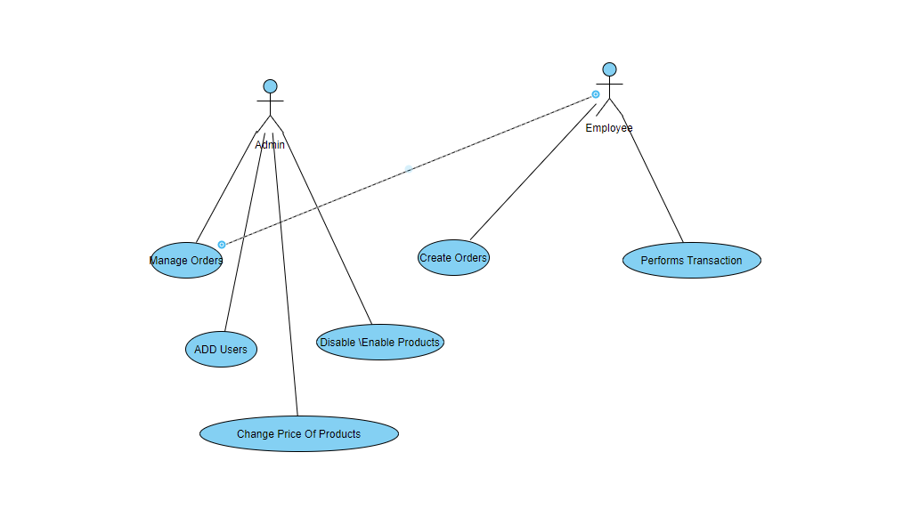

# Technical Feasibility:

**Computers:** Computers are required with sufficient memory and storage from where the Restaurant Management System will work.

**Database**: This system uses the MSSQL database. Database is used to store the information about the products, pricing, and sales.

# Suggested Deliverables:

1. **Requirement**: A document and a presentation to go over the formal requirement of the projects, both non-functional and functional. .This deliverable ensure that the group is working on system that closely matches to the wish of the client.

2. **Design Plan**: A presentation to go over the design of the system. This is the group opportunity to go over how the project is to be design to the client.

3. **Code Implement**: When the project will final it will be represent the document along with code implementation.in previous stages the group designed and developed the final implementation based on the requirements and deliver in this deliverable.

# Visibility

**External:** Our group are regular biweekly meeting with the client. If situation arise or a problem need to be addressed then we contact our client through the email.

**Internal:** we follow the scrum process flow and we meet 30 minute daily to discuss about the project and we contact regular through the WhatsApp and email.

# Risk Management:

* Change requirement :

Client need any change in his system. Depending on the situation, the changes that effect the

Changes to the architecture.

Solution: To reduce the possibility of this situation.

* Staff turnover

Developer during the project may leave the team or project.

* Lack of Resources

In future Clients need to any resource that not available us.

Solution: we will use to change alternate of this and may be arrange resource.

* System Compatibility:

Solution: we plan minimum level of compatibility of our system.

# Conclusion:

This project Restaurant Management System (Food and spicy) is feasible as per given budget time and skills of our team members and also the scope of project. The system software completion will be satisfactory

Fulfill the client's requirements. On the base of this requirement our team decided to go ahead

With this development project